Software Engineering Group 17

The Project Maintenance Manual

|  |  |
| --- | --- |
| Author: | deo4 |
| Config Ref: | SE_N66_xxx_xx |
| Date: | 02/05/2017 |
| Version: | 0.3 |
| Status: | Release |

Department of Computer Science

Aberystwyth University

Aberystwyth

Ceredigion

SY23 3DB

Copyright © Aberystwyth University 2017

CONTENTS

CONTENTS 2

1. Program description 3

2. program structure 4

3. Algorithms 6

4. the main data areas 6

5. files 6

6. interfaces 6

7. suggestions for improvements 6

8. things to watch for when making changes 6

9. physical limitations of the program 6

10. rebuilding and testing 6

REFERENCES 6

dOCUMENT HISTORY 6

# Program description

This program is adapted from the board game Buccaneer, we were told that we needed the program to allow to have four people to play the game the same time on the same computer with the computer prompting each player to make moves when appropriate (explain how this is done). The program will need to keep track of what the player is holding in terms of cards, treasure and what position on the board position the player is currently located (explain how this is done). The game needs to also only allow a player to have two pieces of treasure on the ship at a time while displaying the state of the game to the players onscreen (explain how this is done). The program needs to set up the start position of the game, assigning home ports to players randomly and dealing out crew cards out to players randomly along with applying crew cards and treasure to ports as appropriate (explain how this is done). The program then needs to detect a player reaching Treasure Island, Flat Island or the Anchor Bay, then take any appropriate action (explain how this is done). When a player choses to take a chance card at Treasure Island, the program will implement the consequences of the chance card selected (explain how this is done). The program should be able to manage and exchange of treasure at the ports according to the rules of the game (explain how this is done). The game Should be able to indicate legal moves to a player that is about to move from the rules of the game (explain how this is done). The game will implement the attacking rule when to ships cross (explain how this is done). Finally, the game should detect when a player has won once it has 20 or more points worth of treasure at their home port (explain how this is done).

# program structure

In this part of the manual I will explain the program structure mainly using flow charts, below is a flowchart on moving and turning that shows the start of the game where the users have to enter their names then the game checks if the names entered by the user are legal if there are not a pop up will come up saying one of the names are not legal, then you enter the names again after legal names are entered the game will start to set up following the specs given it will first assign the players to ports after this it will check what user has been assigned the London port as they are first to move the game will present available moves with showing highlighted squares so if a player clicks a non-highlighted square the game does nothing, but when the user does lick a highlights square it will move to that location on the board. Then the player gets the option to turn and will have the available turns highlighted if they chose a non-highlighted the game presents an error message but when the play clicks a highlighted square they turn in that direction.

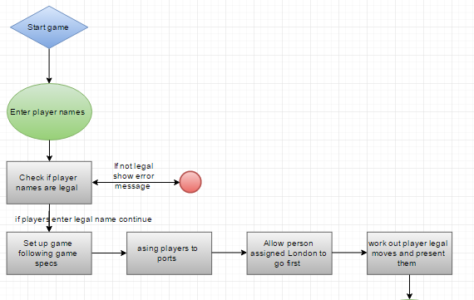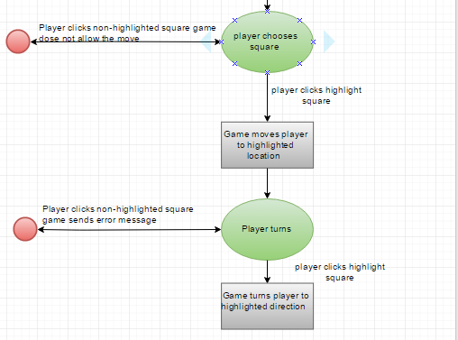

This is a flowchart shows attacking in the game. So, first two of the users in the game are on the same square the game then prompts the attractor seeing if they want to attack if they don’t the game will continue but if they do the game will then work out both of the players attack score, then it will check if the attacker wins or loses if the attacker wins the game then checks if the loser has any treasure if they don’t the two lowest value crew cards will be given to the winner, if the loser has only one crew card then only that will be given to the winner, but then if the loser has treasure on the ship then the winner is awarded the treasure provided they have another room on their ship if they cannot the extra treasure is returned to treasure island after this is done the attacker stays in the same position, the loser also goes through this sequence but doing the opposite but after all that is done the user is then allowed to make a legal move up to the maximum squares hat are available they must at least move on square.

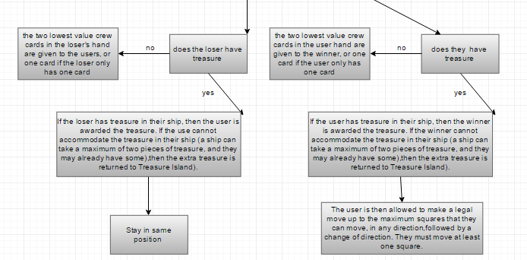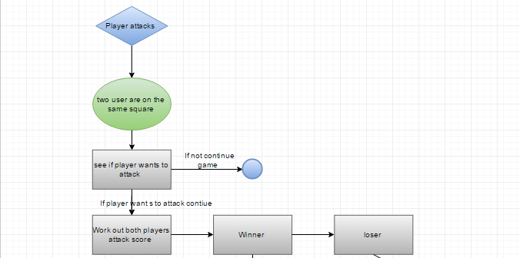

There is more on the program structure in the design specification in sections:

* 2.2 – 2.4
* 3.1
* 4.1 – 4.33
* 5.1 – 5-2

# Algorithms

The algorithms used in this project can be found in the design specification in sections 5.3 and 5.4 one of the main algorithms used in the game is for attacking, moving, trading and attacking these are explained in the design document in section 5.3.

# the main data areas

One of the main data areas is a svc file that contains all the chance cards that we then can call up on when they are needed.

# files

# interfaces

# suggestions for improvements

# things to watch for when making changes

# physical limitations of the program

# rebuilding and testing

# REFERENCES

[1] Software Engineering Group Projects: General Documentation Standards. C. J. Price, N. W. Hardy, B.P. Tiddeman. SE.QA.03. 1.8 Release

dOCUMENT HISTORY

|  |  |  |  |  |
| --- | --- | --- | --- | --- |
| *Version* | *CCF No.* | *Date* | *Changes made to document* | *Changed by* |
| 0.1 | N/A | 02/05/2017 | Layout of document and start of program description needs how it does | Deo4 |
| 0.2 | N/A | 04/05/2017 | Program structure and algorithms almost done | Deo4 |
| 0.3 |  | 05/05/2017 | Explained flow charts in the program structure section and explained where to find information on algorithms started main data areas section | Deo4 |